D.K.T.E. Society’s Textile and Engineering Institute, Ichalkaranji

(An Autonomous Institute, Affiliated to Shivaji University, Kolhapur)
Accredited with ‘A+’ Grade by NAAC

Department of Computer Science & Engineering
Artificial Intelligence and Machine Learning

Academic Year: 2025-2026

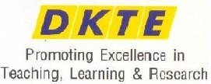

Internship Training
MERN Stack Development

Internship Certificate

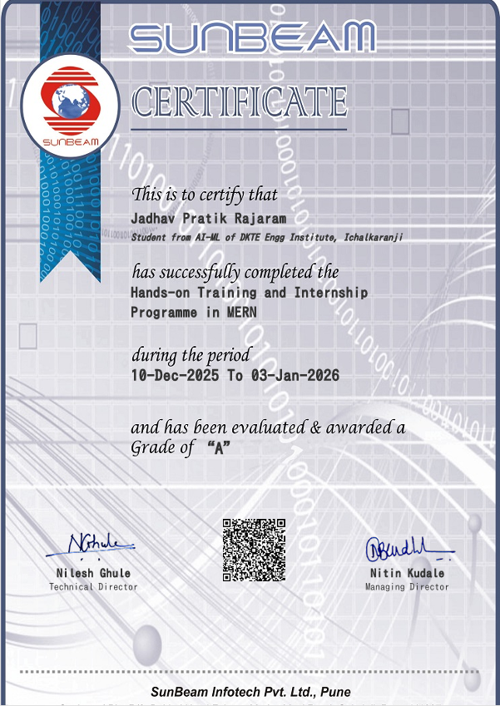

Index

1. Introduction -
2. Problem Statement
3. Problem Solution
4. Project Development steps
5. Tool Used
6. Technologies & Frameworks
7. Working Methodology
8. About the Project
9. Output Provided to the End Client
10. Conclusion

1. Introduction
The Student Learning Platform is a full-stack web application engineered as a Single Page Application (SPA) during a one-month internship at Sunbeam Infotech, Pune. The platform is designed to bridge the operational gap between educational administrators and students by providing a seamless, centralized, and interactive environment for course discovery, enrollment management, and video-based content delivery.
The system is built on a modern MERN-inspired technology stack — React.js (Vite) for the frontend, Node.js with Express.js for the backend REST API, and MySQL as the relational database. Authentication and authorization are implemented using JSON Web Tokens (JWT) with strict role-based access control, creating entirely separate interfaces and permission levels for Administrators and Students.

2. Problem Statement
The initiative to build this platform stemmed from several operational bottlenecks observed in traditional coaching and educational centers. These institutions commonly face the following challenges:
- Manual & Fragmented Record-Keeping: Student enrollments and course data are managed manually, making tracking inefficient and error-prone.
- No Centralized Content Platform: There is no single system for students to browse, enroll, and access course video lectures from one place.
- Unprotected Content Distribution: Distributing premium video content securely to only enrolled, paid students is a significant challenge, risking content leakage.
- Lack of Role-Based Access: Traditional systems lack a mechanism to separate administrator operations from student-facing features, creating security and management gaps.

3. Problem Solution
To resolve these systemic issues, the team developed a full-stack Single Page Application (SPA) to act as a secure, centralized educational hub. This platform replaces manual records by unifying course management, student enrollment, video content delivery, and user data management into a single automated digital framework.
The core solutions implemented include:
- Role-Based Access Control (RBAC): Entirely distinct user interfaces and authorization levels were created for Administrators (course & video management) and Students (browsing, enrollment, video learning).
- JWT Authentication: Every HTTP request to a protected route requires a valid JSON Web Token, ensuring stateless and secure session management without server-side session storage.
- Video Access Expiry: A business-level feature was implemented where video lectures are accessible only within a configured expiry window (video_expire_days) per course, protecting premium content.
- Structured Relational Database: All data — users, courses, students, and videos — is stored in a well-designed MySQL schema with proper Foreign Key relationships.

4. Project Development Steps
The development of the portal followed a structured lifecycle, progressing through the following phases:
- Requirement Gathering & Planning: The initial phase involved identifying core functional needs — student enrollment, secure video access, and admin content management — and designing the system architecture accordingly.
- Database Design: The team designed the MySQL relational schema (sunbeam1), structuring it into four distinct tables: users, course, student, and videos, with appropriate Primary and Foreign Key constraints.
- Backend API Development: RESTful API routes were built using Node.js and Express.js, categorized into Public APIs (no auth), Admin APIs (JWT + admin role), and Student APIs (JWT required) to handle specific system operations.
- Frontend Integration & State Management: The React.js user interface was developed with React Router DOM for navigation and Axios for HTTP API calls. JWT tokens are stored in localStorage and sent in request headers for all authenticated routes.
- Testing & Debugging: The final phase involved rigorous API testing using Postman to simulate HTTP requests, verify endpoint responses, diagnose server errors, and validate JWT authorization flows before final delivery.

5. Tools Used
The project relied on the following core development and testing tools:
- MySQL: Used as the relational database management system to design and manage all structured data. The schema stores user credentials and roles, course catalog data, student enrollment records, and video metadata. MySQL’s relational structure with Foreign Key constraints ensures data consistency across tables.
- Postman: Served as an essential API testing and debugging tool. It was used to send HTTP requests with and without JWT tokens in headers, validate all API responses, and identify and resolve backend issues such as 500 Internal Server Errors, database connection failures, and token authorization failures before frontend integration.

6. Technologies & Frameworks
The platform is built on a modern, clearly separated technology stack:
Frontend (Client-Side):
The user interface is built on React 18 using the Vite build tool for fast development and hot module replacement. React Router DOM enables seamless client-side navigation across pages. Axios handles all asynchronous HTTP requests to the backend API. React Toastify provides real-time user notifications for actions such as login success, enrollment confirmation, and errors.
Backend (Server-Side):
The server logic is powered by Node.js with the Express.js framework, providing a lightweight and efficient REST API server. A global JWT authentication middleware (authUser) protects all secured routes, with specific public routes exempted. CORS middleware is enabled to allow cross-origin requests from the React frontend. The MySQL connection pool (mysql2) handles all database queries efficiently.
Database:
MySQL is used as the relational database (sunbeam1). The schema consists of four tables — users, course, student, and videos — with Foreign Key relationships linking students and videos to their respective courses.

7. Working Methodology
The Sunbeam portal operates on a Stateless System Architecture. The React.js frontend communicates with the Node.js/Express.js backend via JSON REST APIs, which subsequently perform operations on the MySQL database. Since the architecture is stateless, the server does not maintain user sessions. Instead, every protected HTTP request must include a valid JWT token in the request header.
The internship began with a structured training period covering HTML, CSS, JavaScript, React.js, and Node.js/Express.js fundamentals. Following training, the team adopted an incremental development approach — designing the database schema first, building backend APIs next, and finally integrating the React frontend. Each module was independently tested using Postman before integration. Regular collaboration among the four team members and guidance from the Sunbeam mentor ensured steady progress and quality delivery throughout the one-month period.
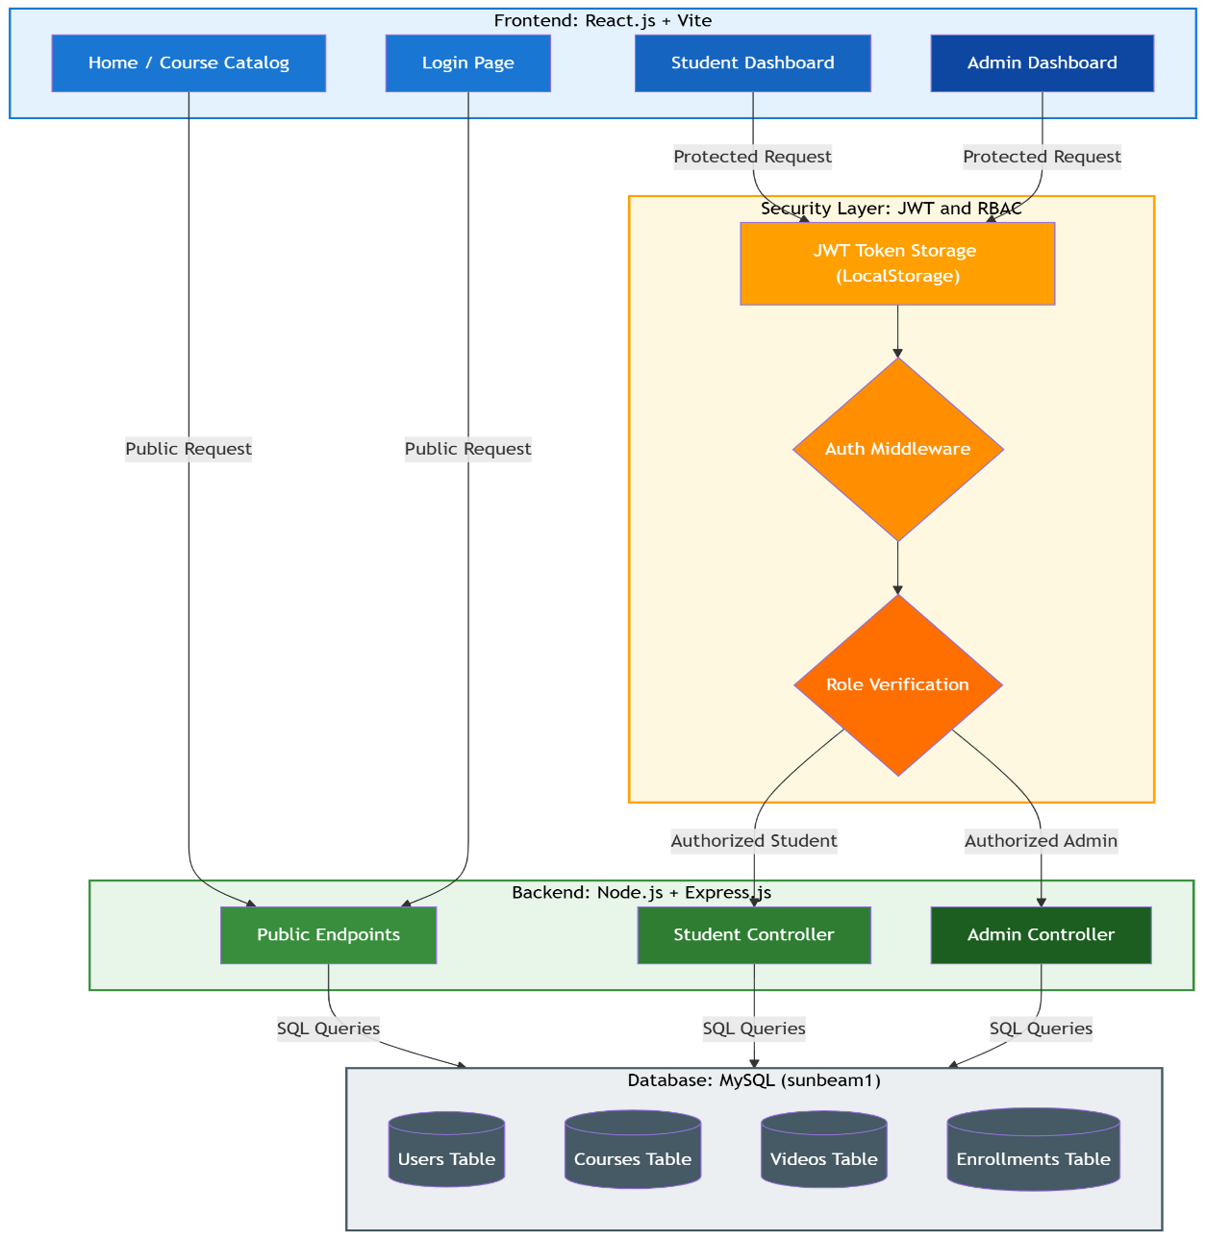

8. About the Project
The Student Learning Platform is structurally divided into two primary operational modules:
The Admin Module:
Accessible exclusively to users with the admin role, this module provides complete course and video lifecycle management. Admins can add, update, and delete courses and videos, configure video expiry settings per course, and view a consolidated list of all enrolled students across the platform.

The Student Module:
The student-facing interface provides a personalized learning experience. Students can browse all active courses and view full course details publicly. After registering for a course and logging in, they can access their enrolled courses via ‘My Courses’, view the full video curriculum for each course, watch YouTube-embedded lecture videos directly within the platform, and manage their personal profile.
The React frontend intelligently switches its layout and available features based on the authenticated user’s role (admin or student), providing a dynamic and context-aware single-page experience.

9. Output Provided to the End Client
The end product delivered two highly capable, distinct interfaces:
For Administrators:
- A full course management dashboard with the ability to add, update, and delete course records including fees, start/end dates, and video expiry settings.
- A video management panel to add, update, and delete video entries linked to specific courses with YouTube URLs.
- A real-time enrolled students list displaying all student registrations across all courses.
For Students:
- A responsive public course catalog with detailed course information (name, description, fees, duration).
- A self-enrollment form requiring only basic details (name, email, mobile number) for quick registration.
- A secure ‘My Courses’ dashboard providing access to enrolled course curricula and YouTube-embedded video lectures within the platform.
- Profile management with the ability to view and update personal information and change passwords.

10. Conclusion
The Student Learning Platform developed during the one-month internship at Sunbeam Infotech, Pune, stands as a scalable, secure, and modern digital solution that successfully modernizes the traditional coaching institute experience. The system simplifies both student and admin operations by providing a structured, role-based, and automated web platform for course management and video-based learning.
By utilizing modern technologies such as React.js (Vite), Node.js, Express.js, MySQL, and JWT-based authentication, the application ensures security, responsiveness, and reliability. The project provided the team with invaluable hands-on experience in full-stack web development, REST API engineering, relational database design, role-based authorization, and collaborative software development. Future enhancements include integrating a payment gateway, implementing bcrypt password hashing, adding per-student video progress tracking, and deploying the application on a cloud platform.

